**Chiroptics empowered by resonant metastructures**

*University of Science and Technology of China, China*

**Yang Chen**

**Email: cyang_phys@ustc.edu.cn**

Chiroptics, as an important branch of optics that studies the photon spin-dependent asymmetry in light-matter interactions, has been widely applied in drug development, asymmetric chemistry, optoelectronic devices, quantum optics, etc. However, there has long been a bottleneck issue in chiroptics: the optical chirality of natural materials is usually quite weak and thus hard to be detected or harnessed. As a solution, resonant metastructures can effectively enhance and modulate optical chirality at the nanoscale. Here, I will present our recent works in this direction. First, I will introduce the achievement of maximum chirality by employing the physics of bound states in the continuum. Second, I will demonstrate the realization of ultracompact chiral light sources based on perovskite metasurface, enabling high degree of circular polarization, large directionality and tunable emission angles. Last, I will introduce enhanced chiral sensing based on high-Q metasurfaces.

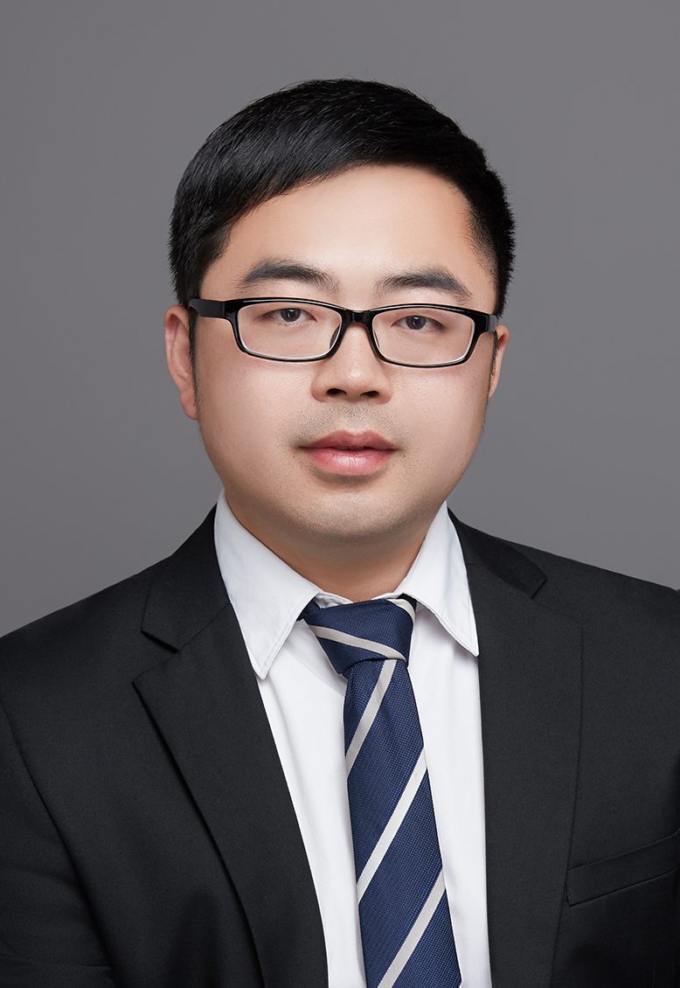**Short Bio:**

Dr. Yang CHEN, got his Bachelor and Ph.D. from University of Science and Technology of China (USTC), and then worked as a postdoctoral researcher in Missouri University of Science and Technology and National University of Singapore (PI: Prof. Chengwei Qiu). In Sep. 2021, he joined USTC as a professor and established an independent group as a principal investigator. He is mainly engaged in the research of nanophotonics, chiroptics, optoelectronics, etc. In recent years, he has first-authored a serious of papers in top journals such as Nature, Nature Nanotechnology, Nature Materials, and Physical Review Letters, which have been widely reported by international media, including Science and Technology Daily, China Science Daily, and Phys.org. He serves as an assistant editor for Photonics Research and a reviewer for many journals. He has won Principal’s outstanding research award and the PhotoniX Prize from the Chinese Society of Optical Engineering. Besides, He has been selected as the National Overseas Young Talent, the Chinese Academy of Science Young Talent and the MIT Technology Review Innovators Under 35 Asia Pacific (MIT TR 35).