**Deep-learning enhanced inverse design of meta-devices**

*China Jiliang University, China*

**Zhongwei Jin**

**Email:** [**jinzhongwei@cjlu.edu.cn**](mailto:jinzhongwei@cjlu.edu.cn)**;** [**jinzhongwei@u.nus.edu**](mailto:jinzhongwei@u.nus.edu)**;**

The advent of ultrathin subwavelength metasurface brings new opportunities to compact and miniaturized optical devices. As the development of computer science, deep-learning neural networks show their ability in the design of meta-devices.

In this report, recent development on inverse design of meta-devices will be introduced, including meta-devices designed based on optimization algorithms and deep-learning neural networks. Meanwhile, we will introduce a phase-only omnidirectional three-dimensional (3D) hologram through a deep-learning neural network. Owing to the strong fitting ability of the proposed deep-learning neural network, the generated omnidirectional 3D hologram has negligible inter-layer crosstalk and high axial resolution. Combining with other degrees of freedom, such as wavelength, polarization, orbital angular momentum and so on, we can push the information capacity of a single meta-hologram to a new level. We believe that the deep-learning enhanced inverse design of nanophotonics can further boost the performance and functionality of the meta-devices to the next level.

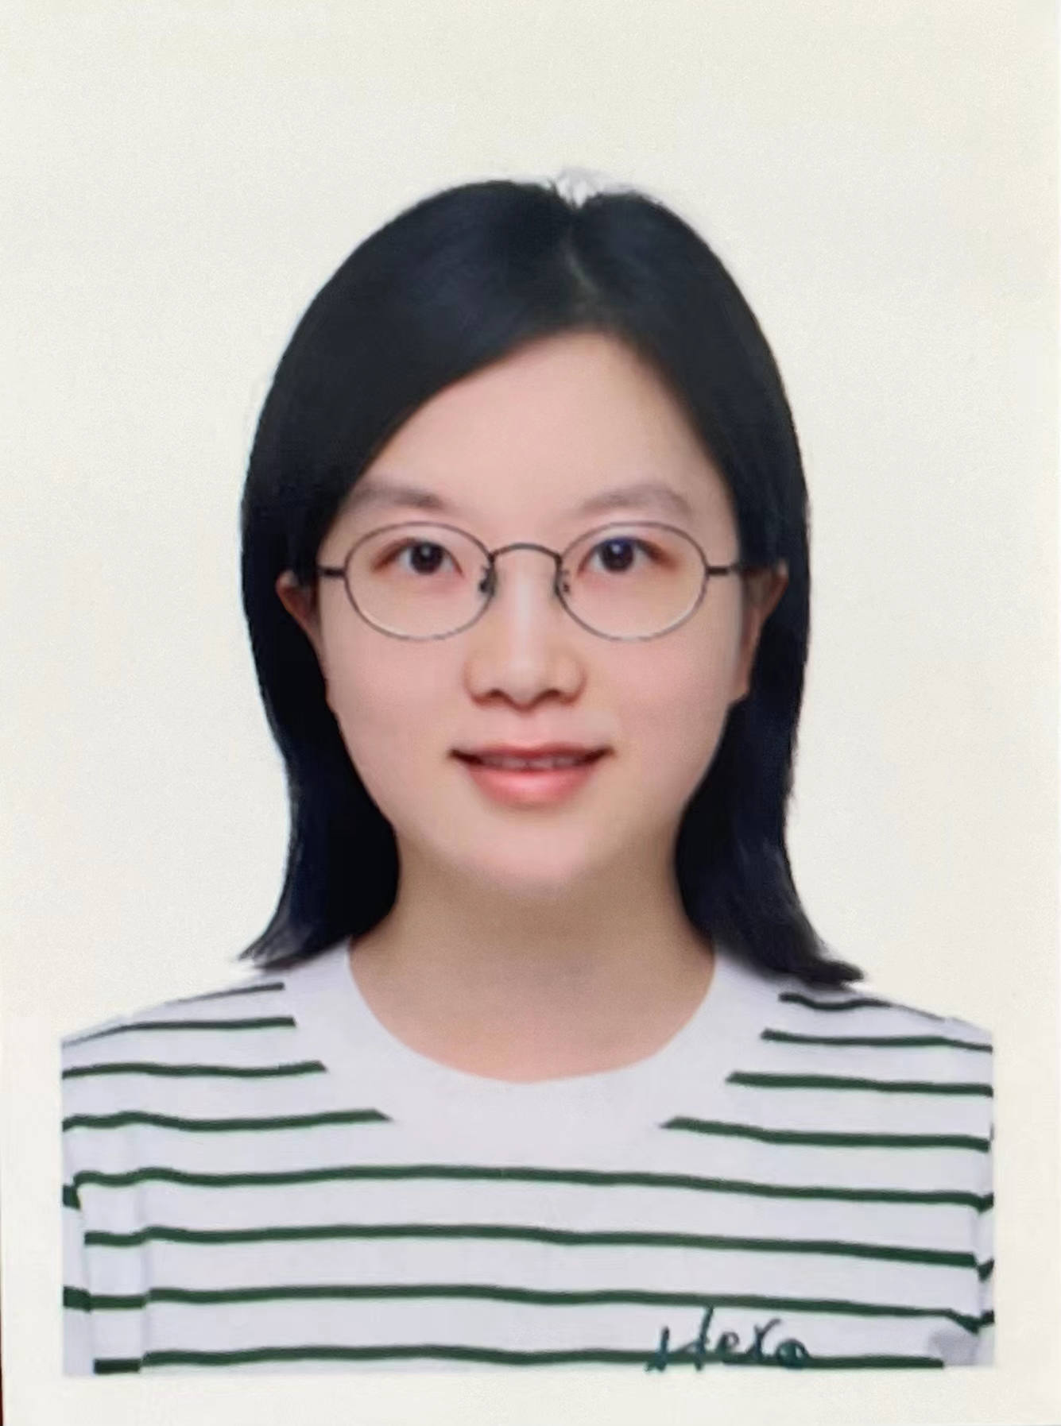**Short Bio:**

**Zhongwei Jin** received her PhD degree in Electrical and Computer Engineering from National University of Singapore, Singapore. She is an associate professor of China Jiliang University, China.