**Optothermal Tweezers for Bio-Nanoparticles Manipulation and DNA Identification**

*Key Laboratory of Optoelectronic Devices and Systems of Ministry of Education and Guangdong Province, College of Physics and Optoelectronics Engineering, Shenzhen University, Shenzhen, 518060, China*

**Jiajie Chen**

**Email: cjj@szu.edu.cn**

Optical manipulation technology leveraging temperature fields offers distinct advantages, including heightened energy efficiency and expanded manipulative capabilities for particles, thus transcending the limitations of conventional optical manipulation methods. This pioneering approach has witnessed significant advancements within the realms of optical tweezers and biomedical research in recent years. By harnessing optothermal phenomena to generate temperature gradients, we have spearheaded the development of an innovative nano-tweezing system propelled by temperature fields.

We recently introduced a highly adaptable optothermal nanotweezer (HAONT) for trapping, sorting, and assembling diverse nanoparticles of varying materials, shapes, and sizes (*Advanced Materials, 2023, 2309143*). This system capitalizes on the synergistic interplay of thermophoresis, thermo-osmotic flow, and other mechanisms, enabling a diverse array of manipulations and identifications of bio-nanoparticles within the size range of 10 nm to 1000 nm.

Furthermore, we have integrated this HAONT with CRISPR biosensing systems. Remarkably, we established an optothermal scheme for enhancing CRISPR-based single-nucleotide polymorphism (SNP) detection at the single-molecule level, while also introducing a novel CRISPR methodology for observing nucleotide cleavage (*Light: Science & Applications, 2023, 12, 273*). We anticipate that the continued refinement of this technology will facilitate the capture and detection of ultra-low concentration biomolecules, as well as enable in-situ single-molecule analysis, thereby significantly contributing to the advancement of biomedical research and its applications.

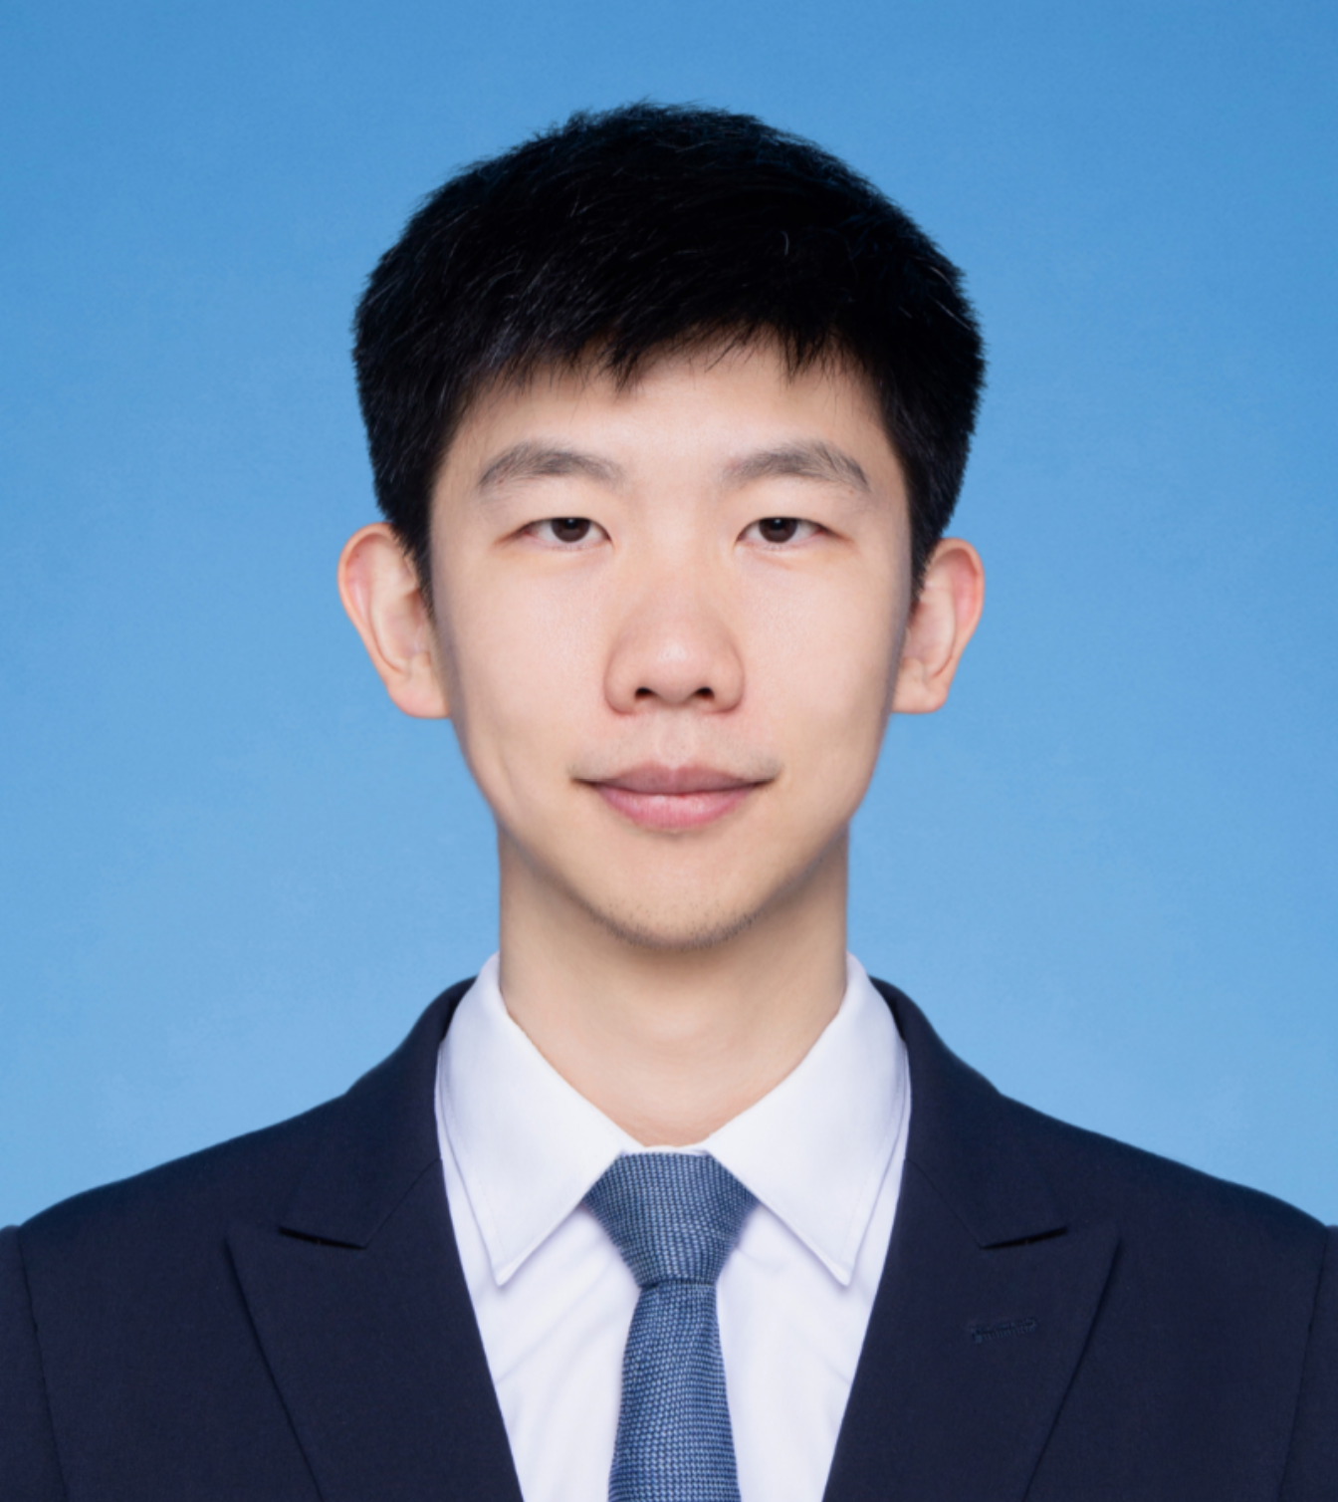

**Short Bio:**

**Jiajie Chen** obtained a Bachelor's degree in Optoelectronic Science from Nankai University and a Ph.D. in Engineering from The Chinese University of Hong Kong (CUHK). He later conducted postdoctoral research at CUHK and the University of California, San Diego (UCSD). He also held positions as a Senior Optical Engineer at the Hong Kong Applied Science and Technology Research Institute and Precise Group Limited. In 2019, he joined Shenzhen University as an Assistant Professor and a Research Fellow. He is also a mentor for graduate students at Shenzhen University. He serves as a Youth Committee Member of the Biomedical Photonics Professional Committee of the Chinese Optical Society and has been recognized as a young talent in Guangdong Province. His research focuses on exploring new methods, phenomena, and structures in nanoscale optothermal tweezers, SPR biosensing, and super-resolution imaging.